Maths
Class XI…Sets…Venn Diagram
. | - Which of the following diagrams indicates the best relation between Travelers, Train and Bus ?
.
  A. | 
  B. | 
  C.
  D. | 
- Which of the following diagrams indicates the best relation between Women, Mothers and Engineers ?
A. | 
B. | 
C.
D. | 

- Which of the following diagrams indicates the best relation between Author, Lawyer and Singer ?
A.
B.
C.
D.

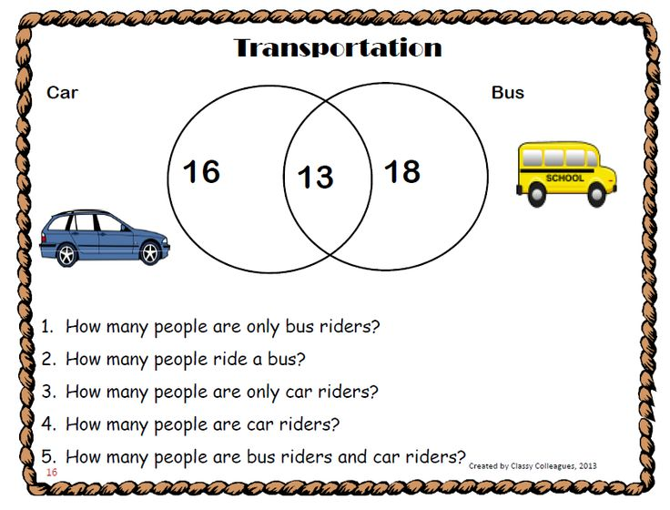

- Is the following figure correct..?

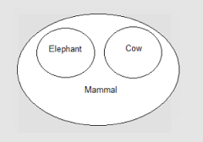
- Frame a Statement for the following figure..?...Write Set A, B and C..?
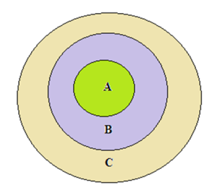

Draw a Venn diagram to represent …
A = { 1, 2, 3, 4, 5, 6, 7 }
B = {2, 3 }
C = { 6.7, 8, 9, 10 }

- Answer the Questions on the basis of the following Venn Diagram
- How many people can Dance..?
- How many can Rap and Dance..?
- How many ppl are proficient in all three ?
- How many ppl are expert in exactly one of the three..?

